1. Preview sebelum order Laundry

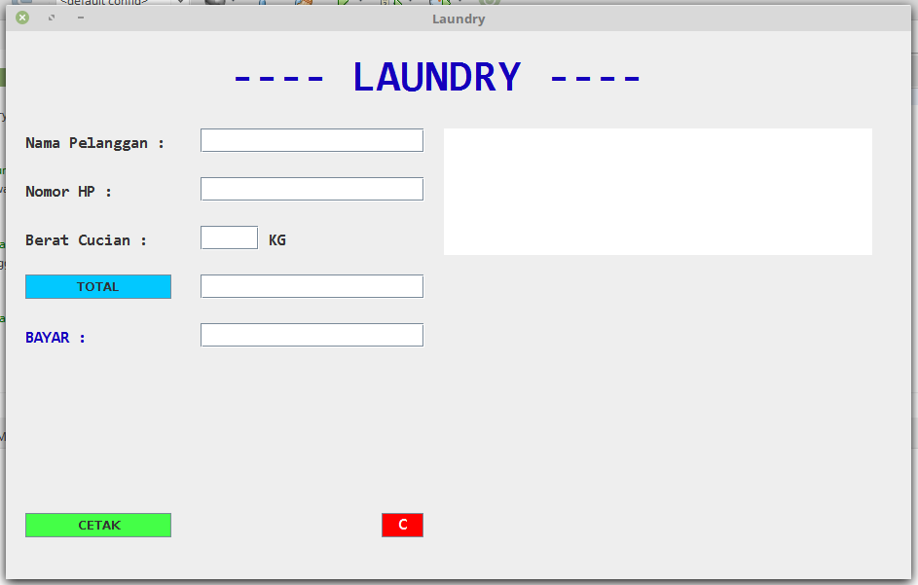

1. Setelah diinput order Laundry

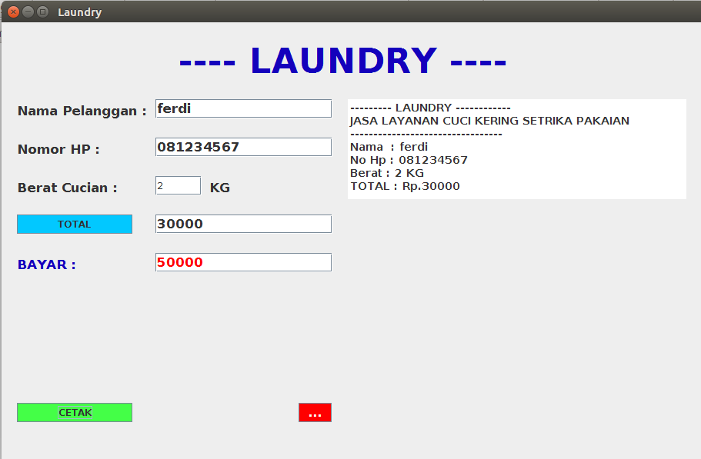

1. Preview no 2

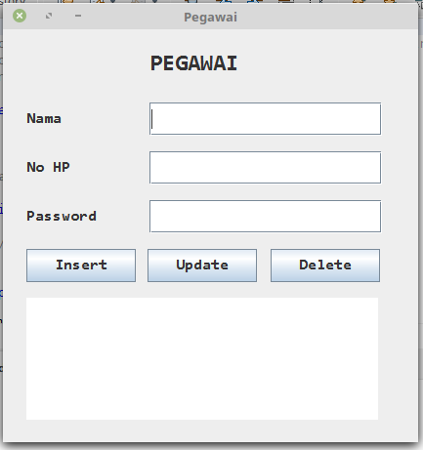

1. Preview no 3

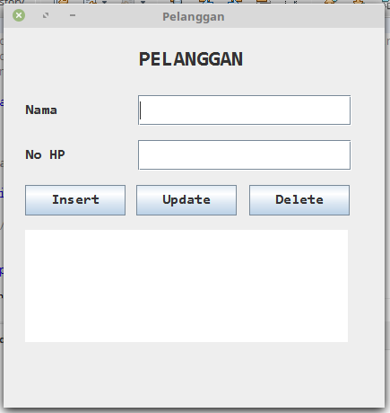

1. Preview no 4

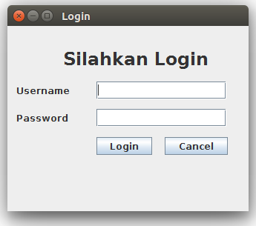

2. Buatlah dan terapkan sourcode untuk membuat tampilan PEGAWAI!

a. sourcode

Class GUI

package npm07079modul6pegawai;

import java.awt.Dimension;

import java.awt.Font;

import javax.swing.JFrame;

import javax.swing.JScrollPane;

import javax.swing.table.TableColumn;

public class GUI extends Komponen {

private static String font = "Consolas";

public GUI() {

lblPegawai.setBounds(150, 25, 300, 22);

lblPegawai.setFont(new Font(font, Font.BOLD, 24));

add(lblPegawai);

lblNama.setBounds(24, 75, 150, 34);

lblNama.setFont(new Font(font, Font.BOLD, 16));

add(lblNama);

txtNama.setBounds(150, 75, 238, 34);

txtNama.setFont(new Font(font, Font.BOLD, 16));

add(txtNama);

lblNoHp.setBounds(24, 125, 150, 34);

lblNoHp.setFont(new Font(font, Font.BOLD, 16));

add(lblNoHp);

txtNoHp.setBounds(150, 125, 238, 34);

txtNoHp.setFont(new Font(font, Font.BOLD, 16));

add(txtNoHp);

lblPassword.setBounds(24, 175, 150, 34);

lblPassword.setFont(new Font(font, Font.BOLD, 16));

add(lblPassword);

txtPassword.setBounds(150, 175, 238, 34);

txtPassword.setFont(new Font(font, Font.BOLD, 16));

add(txtPassword);

btnInsert.setBounds(24, 225, 112, 34);

btnInsert.setFont(new Font(font, Font.BOLD, 16));

add(btnInsert);

btnUpdate.setBounds(148, 225, 112, 34);

btnUpdate.setFont(new Font(font, Font.BOLD, 16));

add(btnUpdate);

btnDelete.setBounds(274, 225, 112, 34);

btnDelete.setFont(new Font(font, Font.BOLD, 16));

add(btnDelete);

tblPegawai.setBounds(24, 275, 360, 125);

tblPegawai.setFont(new Font(font, Font.BOLD, 16));

add(tblPegawai);

setTitle("Pegawai");

setSize(425, 450);

setLayout(null);

setLocationRelativeTo(null);

setDefaultCloseOperation(JFrame.EXIT_ON_CLOSE);

setVisible(true);

}

}

Class Komponen

package npm07079modul6pegawai;

import javax.swing.JButton;

import javax.swing.JFrame;

import javax.swing.JLabel;

import javax.swing.JTable;

import javax.swing.JTextField;

/**

*

* @author ferdi-07079

*/

public class Komponen extends JFrame {

JLabel lblPegawai = new JLabel("PEGAWAI");

JLabel lblNama = new JLabel("Nama");

JLabel lblNoHp = new JLabel("No HP");

JLabel lblPassword = new JLabel("Password");

JTextField txtNama = new JTextField();

JTextField txtNoHp = new JTextField();

JTextField txtPassword = new JTextField();

JButton btnInsert = new JButton("Insert");

JButton btnUpdate = new JButton("Update");

JButton btnDelete = new JButton("Delete");

JTable tblPegawai = new JTable();

}

Class Main

package npm07079modul6pegawai;

/**

*

* @author ferdi-07079

*/

public class NPM07079Modul6Pelanggan

public static void main(String[] args) {

GUI gui = new GUI();

}

}

b. Bukti Running



3. Buatlah dan terapkan sourcode untuk membuat tampilan PEGAWAI!

a. Sourcode

Class GUI

package npm07079modul6pelanggan;

import java.awt.Dimension;

import java.awt.Font;

import javax.swing.JFrame;

import javax.swing.JScrollPane;

import javax.swing.table.TableColumn;

/**

*

* @author ferdi-07079

*/

public class GUI extends Komponen {

private static String font = "Consolas";

public GUI() {

lblPegawai.setBounds(150, 25, 300, 22);

lblPegawai.setFont(new Font(font, Font.BOLD, 24));

add(lblPegawai);

lblNama.setBounds(24, 75, 150, 34);

lblNama.setFont(new Font(font, Font.BOLD, 16));

add(lblNama);

txtNama.setBounds(150, 75, 238, 34);

txtNama.setFont(new Font(font, Font.BOLD, 16));

add(txtNama);

lblNoHp.setBounds(24, 125, 150, 34);

lblNoHp.setFont(new Font(font, Font.BOLD, 16));

add(lblNoHp);

txtNoHp.setBounds(150, 125, 238, 34);

txtNoHp.setFont(new Font(font, Font.BOLD, 16));

add(txtNoHp);

btnInsert.setBounds(24, 175, 112, 34);

btnInsert.setFont(new Font(font, Font.BOLD, 16));

add(btnInsert);

btnUpdate.setBounds(148, 175, 112, 34);

btnUpdate.setFont(new Font(font, Font.BOLD, 16));

add(btnUpdate);

btnDelete.setBounds(274, 175, 112, 34);

btnDelete.setFont(new Font(font, Font.BOLD, 16));

add(btnDelete);

tblPelanggan.setBounds(24, 225, 360, 125);

tblPelanggan.setFont(new Font(font, Font.BOLD, 16));

add(tblPelanggan);

setTitle("Pelanggan");

setSize(425, 450);

setLayout(null);

setLocationRelativeTo(null);

setDefaultCloseOperation(JFrame.EXIT_ON_CLOSE);

setVisible(true);

}

}

Class Komponen

package npm07079modul6pelanggan;

import javax.swing.JButton;

import javax.swing.JFrame;

import javax.swing.JLabel;

import javax.swing.JTable;

import javax.swing.JTextField;

/**

*

* @author ferdi-07079

*/

public class Komponen extends JFrame {

JLabel lblPegawai = new JLabel("PELANGGAN");

JLabel lblNama = new JLabel("Nama");

JLabel lblNoHp = new JLabel("No HP");

JTextField txtNama = new JTextField();

JTextField txtNoHp = new JTextField();

JButton btnInsert = new JButton("Insert");

JButton btnUpdate = new JButton("Update");

JButton btnDelete = new JButton("Delete");

JTable tblPelanggan = new JTable();

}

Class Main

package npm07079modul6pelanggan;

/**

*

* @author ferdi-07079

*/

public class NPM07079Modul6Pelanggan {

public static void main(String[] args) {

GUI gui = new GUI();

}

}

b. Bukti Running



4. Terapkan Exception handling pada password dan username, contoh (username tidak boleh mengandung angka dan simbol dan password minimal 6 karakter)!

a. sourcode

Class GUI

package npm07079modul6login;

import java.awt.Font;

import javax.swing.JFrame;

/**

*

* @author ferdi-07079

*/

public class GUI extends Komponen{

public GUI() {

lblLogin.setBounds(75, 26, 200, 36);

lblLogin.setFont(new Font("Consolas", Font.BOLD, 24));

add(lblLogin);

lblUsername.setBounds(12, 75, 75, 24);

add(lblUsername);

jtxtUsername.setBounds(120, 75, 175, 24);

add(jtxtUsername);

lblPassword.setBounds(12, 112, 75, 24);

add(lblPassword);

jtxtPassword.setBounds(120, 112, 175, 24);

add(jtxtPassword);

btnLogin.setBounds(120, 150, 75, 24);

add(btnLogin);

btnCancel.setBounds(212, 150, 85, 24);

add(btnCancel);

setTitle("Login");

setSize(325, 250);

setLayout(null);

setLocationRelativeTo(null);

setDefaultCloseOperation(JFrame.EXIT_ON_CLOSE);

setVisible(true);

}

}

Class komponen

package npm07079modul6login;

import javax.swing.JButton;

import javax.swing.JFrame;

import javax.swing.JLabel;

import javax.swing.JPasswordField;

import javax.swing.JTextField;

/**

*

* @author ferdi-07079

*/

public class Komponen extends JFrame{

JLabel lblLogin = new JLabel("Silahkan Login");

JLabel lblUsername = new JLabel("Username");

JLabel lblPassword = new JLabel("Password");

JTextField jtxtUsername = new JTextField();

JPasswordField jtxtPassword = new JPasswordField();

JButton btnLogin = new JButton("Login");

JButton btnCancel = new JButton("Cancel");

}

Class Main

package npm07079modul6login;

Public class NPM07079Modul6Login {

public static void main(String[] args) {

GUI gui = new GUI();

}

}

b. Bukti Running

